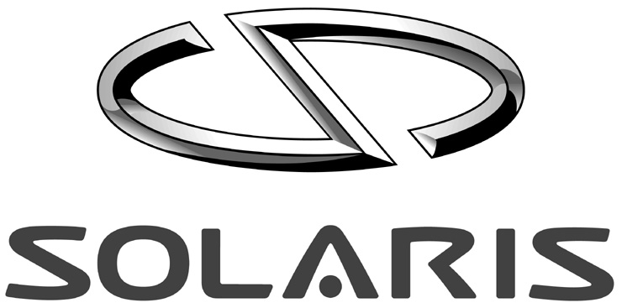
PRESS RELEASE
SOLARIS Bus & Coach S.A.
ul. Obornicka 46, Bolechowo-Osiedle, PL - 62-005 Owińska
Tel. +48 61 81 18 333, Fax +48 61 81 18 310
solarisbus@solarisbus.pl, www.solarisbus.pl

The most environmentally friendly buses in Poland
Bolechowo, 5.12.2007

Eight new articulated Solaris Urbino 18 buses have entered service in the Eastern Polish city of Olsztyn on the 3rd of January, 2007. These are the first vehicles of their kind in Poland, powered by a Diesel engine that already complies with the highest European emission standard, Euro 5. These environmentally friendly buses were purchased by the Olsztyn MPK transportation company within a project called “modernization of infra structure and renovation of rolling stock in public transportation”. This initiative is being sponsored by the European Fund for Regional Development.

Their extremely low exhaust emissions make the Olsztyn Urbino buses ecological pioneers in public transportation. The modern Diesel engine fulfills the strictest ecological emission standard, Euro 5, which is to come into effect only as of October, 2009. In addition, each vehicle has a monitoring system, an aid in the prevention and / or investigation of possible vandalism. The new city buses are capable of transporting 150 passengers, offering 47 of them comfortable seats. The newcomers to Olsztyn are low-floor buses with a kneeling function, helping especially the disabled to easily enter or leave the bus.

The official presentation of the new buses took place at the MPK depot. There, passengers had the unique chance to once sit at the steering wheel of these 18 meter giants themselves. Following the symbolic handing over of the ignition keys, the buses entered their future daily service – they will transport passengers in Olsztyn on lines 3, 15, and 33.

“We are happy to see Olsztyn the first city in Poland, and one of the first Europe-wide, to opt for such modern and environmentally friendly buses, and that they are already now ideally prepared for the Euro 5 standard to come into effect. This investment is a good example for the sensible use of EU funds”, says Krzysztof Olszewski, president of Solaris Bus & Coach S. A.

What is Euro 5?

The European exhaust emission restrictions for heavy vehicles have been defined in the 1999/96/WE guideline and are known as the series of standards Euro 3, Euro 4, and Euro 5. Since October 2006, all newly registered buses must fulfill the Euro 4 exhaust emission standard. The next step in exhaust restrictions, the Euro 5 standard, is to take effect as of October, 2009. The successive implementation of ever stricter exhaust standards forces vehicle manufacturers to continually improve their drive solutions. One example of this is the SCR system (Selective Catalytic Reduction), utilizing the AdBlue catalytic converter.

AdBlue is a chemical product, 32.5 percent of which consisting of an urea solution. It is a non-explosive and environmentally friendly agent. The use of AdBlue allows a decrease in the concentration of nitric oxides in the exhaust fumes, in accordance with the Euro standard. Thanks to this solution, a very high level of exhaust fume purification could be achieved (see chart).

Emission values for Diesel engines according to respective standards in the EU guideline
(ESC-Test)
 | Euro 3 | Euro 4 | Euro 5 | engine DAF PR 265 S2 of the Solaris Urbino 18
CO g/kWh | 2,1 | 1,5 | 1,5 | 0,022
HC g/kWh | 0,66 | 0,46 | 0,46 | 0,06
NOx g/kWh | 5,0 | 3,5 | 2,0 | 1,57
PT g/kWh | 0,10 | 0,02 | 0,02 | 0,018
smoke m⁻¹ | 0,8 | 0,5 | 0,5 | 0,2

The chart above illustrates that through the solution utilized, Solaris Urbino buses produce well less exhaust emissions than even defined in the threshold values of the Euro standards. Already now, the new vehicles are thus well prepared for the implementation of the strictest standard towards the end of the year 2009.

Technical parameters of the Solaris Urbino 18:

Interior length / width / height:
18000 / 2550 / 2850 / 2370 [mm]
Engine: DAF PR265 S2 (265 kW) / euro5
Gear box: ZF 6HP
Tank capacity: 450l
AdBlue-container: 40l
Front suspension: ZF RL 85/A (steif),
Drive axle: ZF AV 132/80
Center axle: AVN 132
Door layout: 2-2-2-2
Seats: Ster 6MN 18000/2550/2850/2370 [mm]

For further information:

Solaris Bus & Coach S.A.
ul. Obornicka 46,
Bolechowo-Osiedle
PL - 62-005 Owińska
Fax.: +48 61 8118 345

Mateusz Figaszewski (Eng, Pl)
Figaszewski_m@solarisbus.pl
Mob. +48 601-652-179

Agnieszka Spiżewska (De, Eng, Pl)
Spizewska_a@solarisbus.pl
Mob. +48 601-659-874

