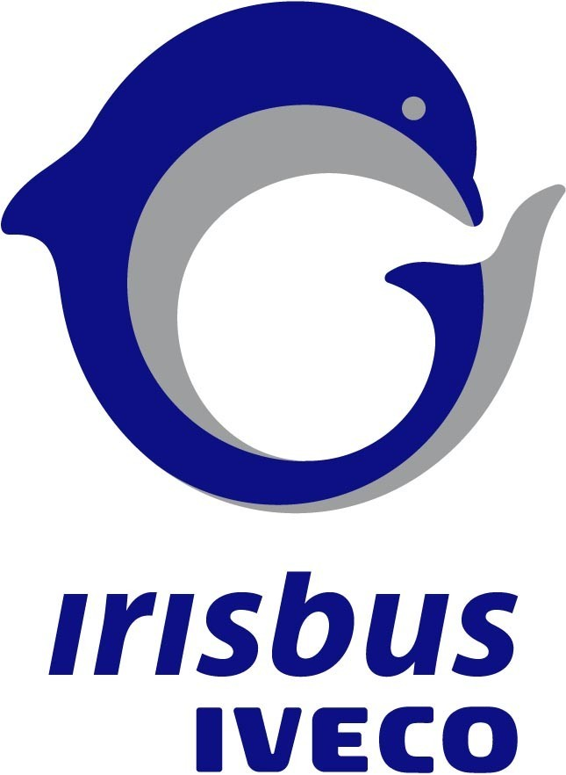

13 June 2007

MAGELYS from Irisbus : a real new concept !

Customer-oriented

A coach developed with, by and for our customers and their customers, those who travel by coach. Nothing has been left to chance: throughout the project we referred to all the actors of the coach, with the different characteristics and typologies of passengers, who obviously have different expectations. New attitudes, new codes: everything is dedicated to the experience. An initiation into a new world. It has been a real corporate strategy. We asked our engineers to work differently; we took the design office out into the field, to find new avenues for innovation, new developments in progress, all types of stakeholders (round tables, clinical tests…).
Complete international market study over a period of 6 months, tourism by coach, coach travel has a very promising future. Two months in a coach to fully grasp all of the different usages of this mode of travel. We identified two main types of usage.

Our concept priority: panoramic visibility in order to

- Change the perception of coach travel, going by coach, especially in this new vehicle, becomes a matter of preference and not just because there is no other choice
- Emphasize the poetry of the itinerary with a more human notion of space and time thanks to the visibility offered by this form of transport and no other, see the passing landscape, a genuine sense of the voyage
- Give a new dimension to coach travel with the addition of verticality. Our gaze moves upward. We look to the heights all during the trip, visibility predominates. Everything has been designed to see better, to open up new perspectives.
The best seats are no longer just in the first few rows behind the driver.

Concerning the exterior design, our motto is: streamlined - a break away from decorative graphics.
Inspired by the trend known as “blob design,” we have eliminated the frontier between the interior and exterior of the vehicle, with maximal usage of glass, even in unexpected places. Progress is not an overbearing presence, it is a given. The technical aspects take a back seat to the desire for transparency.

For the exterior, we have made ample use of rounded and fluid lines, maximum transparency, with ergonomic curves pushed to the extreme. The soft fluidity is subtly combined with a few powerful, taut lines on the wheel housings.
The elegance of the exterior stems from a seemingly simple design, which in fact represents a clear break from standard formalist codes, giving way to a subtle and timeless creativity. The apparent neutrality plays on the senses through a range of customized and sophisticated accessories. The front grill has a stylish steel ornament, like a piece of jewellery discretely enhancing the elegantly refined front of the vehicle.

The rear of the vehicle has not been neglected. It is, in a way, the “other face,” because it is the part of the vehicle most seen by other road users.
Transparency also plays a role in the rear, sloping down discretely to give a reassuring roundness and less imposing appearance. A steel ornament highlights the Irisbus brand, while giving a lighter, nobler look to this part of the vehicle which manufacturers tend to ignore.

Interior ambiance

Inside, we have chosen a sensorial minimalism, not a clinical minimalism, but a generous and comforting minimalism for the passenger, a source of tranquillity.
We have banished grey, opting for sandy and ochre tones: these are deep-rooted colours, the colours of earth, leather, skin, colours which give off a vital, primitive energy, colours which are traditional, permanent, universal, with a strong chromatic character symbolising vigour but also reliability, in a welcoming, comfortable setting.
These colours give a rather classic ambiance to the interior but they also convey a very distinct image of solidity and power.
To soften and buffer this power, we have toned down the colours with light sandy hues. These extremely simple and unassuming pastels delicately decorate the ceiling which blends into its surroundings thanks to the extreme visual lightness emphasizing the clean lines, without decorum. The minimalism subtly evokes refined quality. We took these shades from the frivolous world of cosmetics and lingerie. Sensual and voluptuous, they play an ambivalent role: the emotional nature is provocative and hyper feminine but reassuring because of its timeless, classic elegance.

The tones ranging from ochre to sand play with the natural light and soften the artificial light. The LEDs also give a new creative dimension to the light by making it soft and warm. A precious ally, the light serves to clothe and structure, to reveal or hide the volume of the ceiling. It communicates a feeling of comfort and quality, while the blue of the guidance lights conveys performance and efficiency and allows passengers to move around safely.

Our stylistic choices give priority to the senses: rational aspects increasingly give way to an efficient emotionalism. We looked for simplicity, and it is in the soft flowing shapes that we found harmony. All is round, soft and curved to protect and reassure the passenger.

We sought the authenticity of a proven value that allows a form of regression, a return to the essential, like a desire for truth and beauty. This naturally led to the choice of simplicity, depth and density for the materials. The flooring of the Magelys elicits multiple sensations and perceptions:
- First, the authenticity and warmth of the material conjure up sentimental values (the parquet floors of childhood, attenuating the separation from the home setting)
- Then comes the marvel of technology (it tricks our senses ; we lose our bearing ; the solidity and visual power of the material is countered by the soft comfort we feel underfoot …)
- The same is true of respect for the environment: wood not only offers aesthetic qualities, it also has the technical advantage of being recyclable and has been treated for heavy usage.

This material takes us into both the past and the future; it evokes the symbols and traditions of yesterday and today.

The seat plays a key role in the pleasure of the trip.
Travelling is a question of being separated from home and we have to transform that into a positive experience. The passenger must be able to make the space his own. Beyond the purely functional aspects, the seat must become more human, more harmonious. The constraint of being with others and the negative feeling of promiscuity are transformed into an occasion for sharing, in a calm place, where the technical features give way to a certain magic which makes us forget the obligation to be seated and the feeling of coercion, especially for the passenger seated by the panoramic window.

The idea is to combine performance and high technology with a more personal charm and harmony.

To make the seats visually less present, less technical.

The increasingly diverse morpho-physiological profile of passengers requires intelligent design and adaptability of the seat.

TECHNICAL SPECIFICATIONS

PASSENGER WELL-BEING

More headroom
Not only with its 2100mm inner free height is Magelys the best in its product category but in first with its ability to offer to the window seated passenger to stand up without touching the luggage racks by his head.
This is giving to all passengers much more free space feeling.

Video
Magelys being equipped by 3 foldable 15inches or even 19inches monitors is giving to all the passengers the same pleasure of a movie regarding.
And as an option we are offering another dimension of a movie regarding or music listening pleasure: real individual monitors and headphones sockets.
Every passenger can choose his own preferred movie or music and watch and hear it with 100% independence of its neighbour.

Toilet cabin
Irisbus designed a new toilet cabin for Magelys.
This toilet cabin offers not only a very large interior space and easy entrance but as a small additional value also a storage space integrated in the upper part which can be transformed as in a space for coffee machine or additional refrigerator.

Thermal comfort
Our product was designed in the way to offer 100% flexibility to our customers concerning the interior seats layout changes during the productive life of New Coach.
What that means? That means that in every seats layout case you are covered by individual air nozzles because we put them enough on the roof (only in 30cm distances between each other) so as each passenger can in every time reach at least 1 or 2 of them and oriented like he wishes.
Concerning the individual spot lights no problem because we put them on the seats backrests, so they move with the seats.

With Magelys let’s forget the top roof air conditioning units which are disturbing the design. Our air conditioning is fully integrated in the vehicle and their parts are also much more accessible for regular checks.
The power of our air conditioning allows reducing the interior temperature in very short time and keeping the temperature homogeny from front to the rear for all passengers.
The complete system of heating and air conditioning is controlled by automat where you set up the temperature and that’s it. Of course, if you want to take the manual control of it, it is also possible.
This control is concentrated in one panel with a display and a set up is possible separately for passenger zone and driver/hostess zone.

PASSENGERS SEATS

Irisbus developed not only a new coach but also an especially designed and shaped new seat model which is reservated only for Magelys.
This new seat is designed following an ergonomic study and shaped to be very comfortable for long distance travelling.
Customer has the choice of several upholstery possibilities up to the leather upholstery.
This seat like the complete vehicle matches all international and national comfort classification standards up to the 5 stars standard (as UCAT requested in France, GBK in Germany & Alps, FBAA in Benelux and of course IRU for all other countries).

Our new seat installation in the vehicle is respecting the request of the luxury tourism segment and is giving always the priority to the seating passengers. It means that we reduced a little bit the aisle width to bring a maximum comfort for passengers on their seats. But of course on a special customer request we are able to do in opposite- reduce a little bit the transversal seats distances to increase the aisle width.
Another important improvement is represented by the LED-spot lighting integrated in the seats backrests which means more lighting efficiency but also privacy for each passenger.
The hostess call function is also integrated in the seat backrest.
We also developed a new individual bins and 1.5lt. bottle holders fitted under each double-seat

HOSTESS

In Magelys is hostess place treated as a passenger place and not as a place for somebody who does not pay the ticket so does not the same travelling condition.
Hostess has a seat with the same comfort like inclinable backrest, armrests, hostess has also its own storage space above and beside of its seat, the small table, spotlight and air nozzle.
Hostess can accede very easily from the seat to the dashboard panel with all controls of comfort settings like audio-video and thermal comfort for herself and for passengers.
Optionally we can add also the integrated camera bringing the hostess face to the monitors of all passengers or plug in sockets of a PC or audio/video or MP3 player where any other source of sound or image can be linked with on board audio-video systems.

DASHBOARD

Driver’s dashboard is brand new for the Magelys. It is separated very ergonomically in three zones. On the left side are commands of auxiliary functions ; on the right side are controls of everything related to the comfort (audio video, heating, air conditioning and navigation). There is also a holder plus 12V socket for the mobile phone and a drivers refrigerated box.

In the middle of the dashboard is the steering wheel with integrated control buttons for audio and board computer and also the control of ASTronic gearbox is just under the steering wheel.

Driver Cluster
Cluster design is integrated to the interior colour harmonies.
In the middle is a big LCD screen linked to the board computer where the driver can in very simple way see and control most of vehicle functions.
As a plus we integrated to this screen the image of reverse camera and middle door area. If the driver engages reverse gear, automatically an image of reverse camera appears on this screen and the same in case of opening middle door, immediately is shown the image of middle door-steps area.

ACCESSIBILITY

Magelys is very easy to board on for all kind of passenger types. As well as for the children as for the seniors.
It is the right choice of each steps height and depth and grab handles position and shape that onboard getting up is so easy for everybody.
To avoid any doubt, in the dark or night time the front door area is very well lighted even outside of the vehicle.
The steps in front and in the rear are anti-slip and moulded of one plastic piece so as their cleaning is very simple and fast. And the first step is provided with a integrated shoes brush carpet to facilitate the cleaning work of passenger compartment.

DRIVER MIRRORS

Driver has excellent rear and all angles visibility all around the vehicle which are largely exceeding the compulsory visibility requested by all regulations.
Both exterior mirrors are foldable to assure easier cleaning or narrow streets passing of vehicle. Optionally their folding could be remote controlled from drivers place.

SAFETY

EBS/ESP
Magelys has in its standard equipment ESP. There is no need to re-explain the advantages of ESP because they are very well known not only in coach industry.

Adaptive Cruise control and Lane guarding system
What is for the time being a little bit less spread in the coach industry is the adaptive Cruise control and Lane guarding system. We are offering both as an option but we believe that in next future the price mainly of adaptive cruise control will decrease due to the large application in cars, truck and bus industry and we will be able to include them into serial equipment as ESP.

Bi-xenon headlights
Bi-xenon lights are very efficiently improving the night visibility for the driver.
You can see what is the difference in lighting efficiency (case of crossing lights) between bi-xenon headlights and conventional headlights.
For this reason we decided to put on Magelys bi-xenon lights as a standard equipment.

STORAGE

Interior luggage racks are shaped and designed so as a standardized aircraft cabin luggage is able to fit it.
The luggage lockers situated under the floor are big enough to be filled in by every size of passenger luggage.
In case of HDH version the luggage lockers are horizontally separated in two levels so as the load in and load out of all luggage could be easier and faster.

ENGINE CHARACTERISTICS

Magelys is powered by the Iveco Cursor 10 very well appreciated engine offering high torque, high power, long lifetime and optimized fuel consumption.
Magelys like all other Irisbus models can be delivered to all customers with a Euro 5 or EEV emissions levels homologation certificate.

Magelys is not only one model but a range with 4 lengths and 2 heights, in 4x2 or 6x2 concept offering large possibilities to all needs of customers.
As you can see, we developed this product also in 12,8m length in 4x2 concept even though some of bus industry professionals are sceptic to pass over 12,2m in 4x2 concept.
The reason is that our experience and research proved 12,8m on 2 axles very interesting for some customers and seat layouts.

Régine DEBERNIS Nicolas TELLIER
Tél 33 (0) 4 72 79 67 52 Tél 33 (0) 1 41 44 51 77
Fax 33 (0) 4 72 79 66 78 Fax 33 (0) 1 41 44 51 62
regine.debernis@irisbus.iveco.com nicolas.tellier@irisbus.iveco.com

